The Islamia University of Bahawalpur

Department of Computer Science

SOFTWARE DESIGN DESCRIPTION DOCUMENT (SDD DOCUMENT)
for
BloodLink App (Smart Blood Donation App)
Version 1.0

By
Noor Mustafa
Roll No: F22BDOCS1M01160
Session Fall 2022 – 2026

Supervisor
Mam Siddiqa Ajmal

Bachelor of Science in Computer Science

Revision History
Date | Description | Author | Comments
<11/12/2025> | <Version 1> | <Noor Mustafa> | <First Revision>
<15/12/2025> | <Version 2> | <Noor Mustafa> | <Second Revision>
<17/12/2025> | <Version 3> | <Noor Mustafa> | <Third Revision>
<19/12/2025> | <Version 4> | <Noor Mustafa> | <Fourth Revision>

Document Approval
The following Software Requirements Specification has been accepted and approved by the following:
Signature | Printed Name | Title | Date
 | Mam Siddiqa Ajmal | Supervisor, CSIT 21306

Table of Contents
Contents
1. INTRODUCTION 5
1.1 Purpose 5
1.2 Scope 5
1.3 Overview 6
1.4 Reference Material 6
1.5 Definitions and Acronyms 7
2. SYSTEM OVERVIEW 8
3. SYSTEM ARCHITECTURE 8
3.1 Architectural Design 8
3.2 Decomposition Description (Object-Oriented Description) 10
3.3 Design Rationale 16
4. DATA DESIGN 17
4.1 Data Description 17
4.2 Data Dictionary 18
5. COMPONENT DESIGN 21
5.1 User Component (Account & Role Behavior) 21
5.2 Profile Component (User Profile & Donor Availability) 22
5.3 BloodRequest Component (Request Lifecycle Management) 23
5.4 Admin Component (Monitoring & Management) 25
5.5 SystemRepository Component (Logical Data Store) 26
6. HUMAN INTERFACE DESIGN 27
6.1 Overview of User Interface 27
6.2 Project Screen Images 28
6.3 Screen Objects and Actions 33
7. REQUIREMENTS MATRIX 36
8. APPENDICES 37

1. INTRODUCTION

1.1 Purpose
The purpose of this Software Design Document (SDD) is to describe the high-level design and structural organization of the BloodLink (Smart Blood Donation System). This document translates the functional and non-functional requirements defined in the approved Software Requirements Specification (SRS) into a coherent design blueprint that guides system implementation, integration, and testing.
The SDD provides an overview of the system architecture, major software components, data structures, interfaces, and design rationale without addressing implementation-specific details such as source code or programming logic. It serves as a reference for developers to understand how system components interact, how data flows through the system, and how design decisions support the stated requirements.
This document is intended to ensure consistency between requirements and implementation, reduce ambiguity during development, and support maintainability and scalability of the BloodLink system. It also facilitates communication among stakeholders by presenting the system design in a structured and understandable manner.

1.2 Scope
This Software Design Document (SDD) covers the architectural and structural design of the BloodLink (Smart Blood Donation System). The scope of this document includes the definition of the system’s overall architecture, subsystem decomposition, component interactions, data design, and human–system interfaces.
The SDD focuses on explaining how the BloodLink system is organized internally to support its core functionalities, including user role management (donor, recipient, and administrator), donor–recipient matching, blood request handling, availability management, and administrative monitoring. It describes the relationships between major components, the flow of data between system layers, and the design decisions that ensure scalability, security, and maintainability.
This document does not include detailed implementation logic, source code, or technology-specific configurations. Instead, it provides a design-level view that serves as a bridge between the approved Software Requirements Specification (SRS) and the actual system implementation. The scope of this SDD is limited to the current version of BloodLink and may be revised in future releases to accommodate system enhancements or additional integrations.

1.3 Overview
This Software Design Document (SDD) is organized to present the design of the BloodLink (Smart Blood Donation System) in a clear and structured manner, allowing readers to easily locate information relevant to their roles and interests.
Section 2 provides a high-level overview of the BloodLink system and introduces the design context in which the system operates. It summarizes the system’s purpose, major components, and overall operational environment from a design perspective.
Section 3 describes the system architecture in detail, including the architectural style, subsystem decomposition, component responsibilities, and design rationale. This section is primarily intended for developers and technical reviewers who require an understanding of how the system is structured internally.
Section 4 focuses on data design, presenting the organization of data, key entities, relationships, and the data dictionary used by the system. Section 5 explains the component-level design, outlining the responsibilities and interactions of major software components without exposing implementation details.
Section 6 addresses human interface design, describing how users interact with the system through different interfaces. Finally, Section 7 presents the requirements traceability matrix, demonstrating alignment between the system design and the approved Software Requirements Specification (SRS).
This organization ensures that the document supports effective system development, review, and maintenance while maintaining a clear separation between requirements and design.

1.4 Reference Material
List The following documents and resources were referenced during the preparation of this Software Design Document (SDD) for the BloodLink (Smart Blood Donation System). These materials provide background information, standards, and contextual guidance relevant to the system design.
- Software Requirements Specification (SRS) for BloodLink (Smart Blood Donation System)
Approved project document defining functional and non-functional requirements that serve as the basis for the system design.
- IEEE Std 1016™ – IEEE Standard for Software Design Descriptions
Publishing Organization: Institute of Electrical and Electronics Engineers (IEEE)
This standard provides guidelines for organizing and documenting software design information and has been followed in structuring this SDD.
- Django Official Documentation
https://docs.djangoproject.com
- Flutter Official Documentation
https://flutter.dev
- PlantUML / UML Modeling References
https://plantuml.com

1.5 Definitions and Acronyms
This subsection defines the key terms, acronyms, and abbreviations used throughout this Software Design Document (SDD) that may not be familiar to all readers. These definitions are provided to ensure a clear and consistent understanding of the design concepts described in this document.
Term / Acronym | Definition
SDD | Software Design Document; a document that describes the architectural and detailed design of a software system.
SRS | Software Requirements Specification; a document that defines the functional and non-functional requirements of the system.
UML | Unified Modeling Language; a standardized modeling language used to visualize system design through diagrams.
Component | A modular and replaceable part of the system that encapsulates a set of related responsibilities.
Subsystem | A logical grouping of components that together provide a major system function.
Client–Server Architecture | A system design model where client applications request services from a centralized server.
Donor | A registered user who is willing to donate blood and make their availability visible to recipients.
Recipient | A registered user who searches for donors and sends blood donation requests.
Administrator (Admin) | A privileged user responsible for monitoring system activity and managing users and requests.
Traceability Matrix | A table that maps system requirements to corresponding design components to ensure coverage and consistency.
Data Dictionary | A structured description of data elements, their types, and their purpose within the system.

2. SYSTEM OVERVIEW
The BloodLink (Smart Blood Donation System) is a client–server based software system designed to facilitate efficient and secure interaction between blood donors, recipients, and system administrators. The system provides a unified platform where donors can manage their availability, recipients can search for suitable donors and submit blood requests, and administrators can monitor and manage overall system activity.
From a design perspective, BloodLink is organized into three primary layers: a client layer, a server layer, and a data layer. The client layer consists of a mobile application used by donors and recipients, as well as a web-based interface used by administrators. The server layer is responsible for handling business logic, access control, request processing, and coordination between system components. The data layer manages persistent storage of users, profiles, blood requests, and system records.
The system supports role-based access, allowing a single user to operate as a donor or a recipient depending on context. Communication between clients and the server follows a structured request–response model, enabling real-time data exchange while maintaining system security and integrity.
This overview establishes the design context for the sections that follow, which describe the system architecture, component decomposition, data organization, and interface design in greater detail.

3. SYSTEM ARCHITECTURE

3.1 Architectural Design
The BloodLink (Smart Blood Donation System) is designed using a modular, layered architecture to ensure separation of concerns, maintainability, and scalability. System responsibilities are partitioned into high-level subsystems based on user roles (Donor, Recipient, Admin) and core business processes (authentication, donor discovery, request handling, and monitoring). Each subsystem encapsulates related responsibilities and collaborates with other subsystems through well-defined interfaces.
At a high level, the system is decomposed into the following subsystems:
1) Client Subsystem (Mobile Application)
This subsystem provides the user-facing interface for donors and recipients. It is responsible for screen navigation, form input, displaying donor lists, showing request status, and capturing user actions. It communicates with the backend through structured request–response interactions.
2) Authentication & Role Management Subsystem
This subsystem manages user identity, access control, and role-based navigation. It validates user credentials, determines the active role (donor or recipient), and enforces restrictions so users can access only the features allowed for their selected role.

3) Donor Management Subsystem
This subsystem manages donor profile data and donor availability. It handles donor-specific information such as blood group, city/area, contact details, profile image, and availability status. It ensures that only available donors are surfaced to recipients during donor discovery.
4) Recipient Search & Matching Subsystem
This subsystem enables recipients to search for donors using filters such as blood group and city/area. It applies matching rules and ensures only eligible donors are returned (e.g., excluding donors already having a pending request from the same recipient).
5) Blood Request Handling Subsystem
This subsystem manages the complete lifecycle of blood requests. It supports request creation, validation (e.g., duplicate prevention and request limits), request status updates (pending/accepted/rejected/fulfilled), donor responses, and controlled information disclosure (e.g., revealing contact details when a request is accepted).
6) Admin Monitoring & Management Subsystem
This subsystem supports administrative oversight, including viewing system statistics, monitoring users and requests, filtering records, and reviewing suspicious or abnormal activity. It provides a controlled interface for administrators to manage system operations without interfering with donor–recipient workflows.
7) Data Persistence Subsystem (Database Repository)
This subsystem represents the persistent storage of system entities such as user accounts, profiles, and blood requests. All subsystems that require stored data interact with this repository through controlled data access operations to maintain consistency and integrity.
Subsystem Collaboration
- The Client Subsystem initiates actions such as registration, login, donor search, and request creation.
- Authentication & Role Management validates access and activates the correct workflow (donor/recipient/admin).
- Donor Management and Recipient Search & Matching collaborate to provide accurate donor lists based on availability and filters.
- Blood Request Handling coordinates interactions between donors and recipients by managing request states and responses.
- Admin Monitoring & Management reads aggregated system data and activity logs for oversight.
- All subsystems rely on the Data Persistence Repository for storing and retrieving system records.

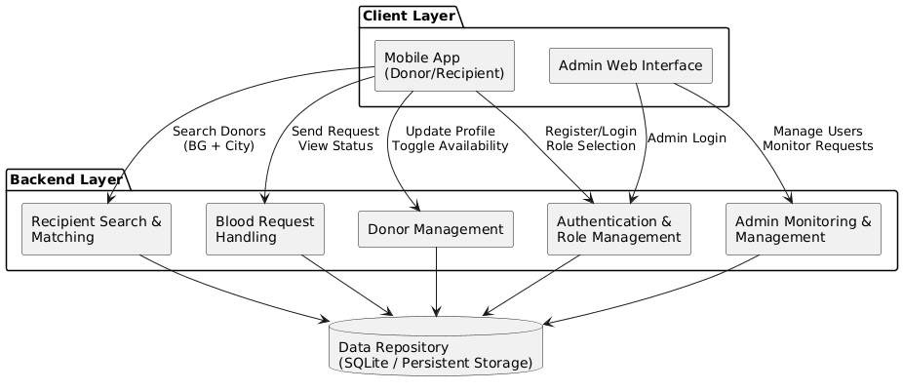
Figure 3.1 Architecture Diagram

3.2 Decomposition Description (Object-Oriented Description)
This section decomposes the BloodLink (Smart Blood Donation System) into logical subsystems and design-level objects to explain how the overall architecture is partitioned into collaborating parts. The decomposition is presented using an object-oriented view, where responsibilities are grouped into subsystems and core entities represent persistent system data. This description supports clarity, traceability, and modular implementation while keeping the design independent from source-code details.
3.2.1 Subsystem Model
BloodLink is decomposed into the following major subsystems. Each subsystem encapsulates a set of related responsibilities and interacts with others through well-defined service boundaries.
- Authentication & Role Management Subsystem
- Responsibilities: user authentication, session management, role selection (donor/recipient/admin), access control enforcement.
- Collaborates with: User/Profile Data objects, all other subsystems (for authorization).
- User & Profile Management Subsystem
- Responsibilities: create/update user profile, manage donor-specific attributes (blood group, city/area, phone), profile picture handling, maintain donor availability status.
- Collaborates with: Authentication subsystem, Donor Search subsystem, Request Handling subsystem.
- Donor Search & Matching Subsystem
- Responsibilities: filter donors by blood group, city/area, and availability; apply exclusion rules (e.g., hide donors with active pending requests from the same recipient).
- Collaborates with: Profile objects, Request objects, Authentication subsystem.
- Blood Request Handling Subsystem
- Responsibilities: create request, validate request rules (duplicate prevention, active limit), update request status (pending/accepted/rejected/fulfilled), store donor responses, controlled disclosure of donor contact after acceptance.
- Collaborates with: Profile objects, Request objects, Admin subsystem (for monitoring).
- Admin Monitoring & Management Subsystem
- Responsibilities: system dashboard metrics, user and donor listings, request logs, filtering and inspection of records, oversight of suspicious activity (if applicable).
- Collaborates with: all persisted objects through the data repository.
- Data Persistence Subsystem (Repository)
- Responsibilities: persistent storage and retrieval of Users, Profiles, Blood Requests; ensures data consistency and integrity via structured operations.
3.2.2 Key Design Objects (Domain Model Summary)
The following core objects represent the primary domain entities of BloodLink. These objects are referenced by multiple subsystems and form the basis for data design and class modeling.
- User: represents an authenticated account identity used for system access.
- Profile: represents extended user information including donor attributes and availability.
- BloodRequest: represents a request initiated by a recipient to a donor, including status and messages.
- AdminUser (logical role): represents privileged access for monitoring and management functions (may be treated as a role of User).

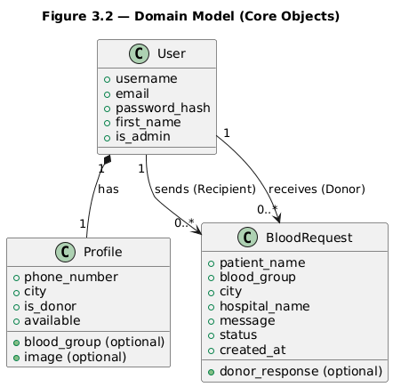
Figure 3.2 Domain Model

3.2.3 Generalization and Aggregation Relationships (High-Level)
- Generalization (if any):
BloodLink primarily uses role-based behavior rather than separate inheritance trees. Donor, Recipient, and Admin are treated as user roles rather than independent subclasses to keep the model simple and flexible.
- Aggregation / Composition (if any):
  - A User has one Profile (composition relationship, profile is logically tied to the user).
  - A User (Recipient) may create many BloodRequest records.
  - A User (Donor) may receive many BloodRequest records.
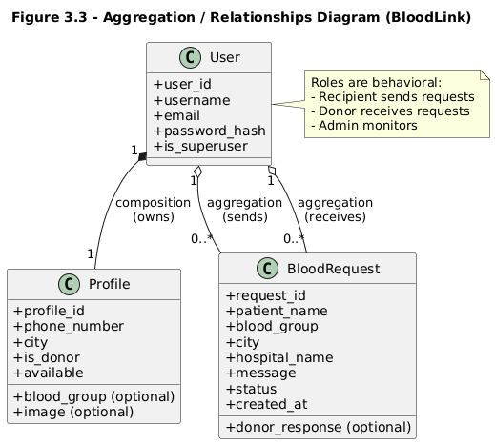
Figure 3.3 Relationship Diagram
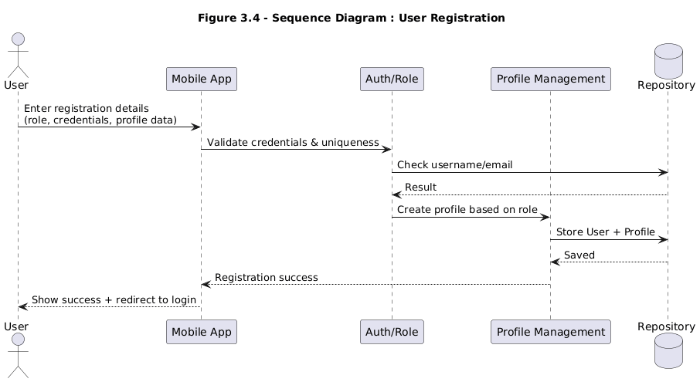
Figure 3.4 Sequence Diagram

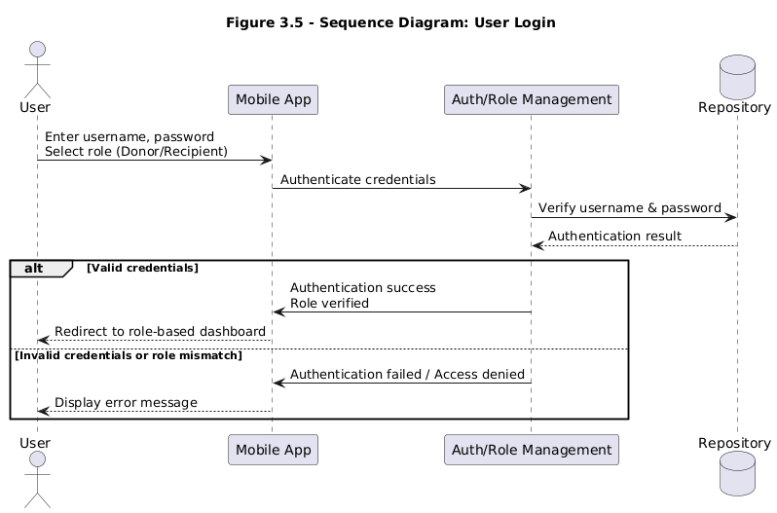
Figure 3.5 Sequence Diagram User Login
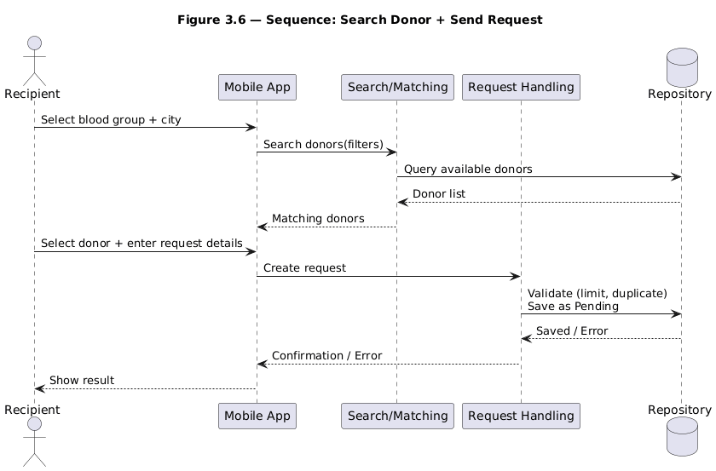
Figure 3.6 Sequence Diagram Search Donor & Send Request

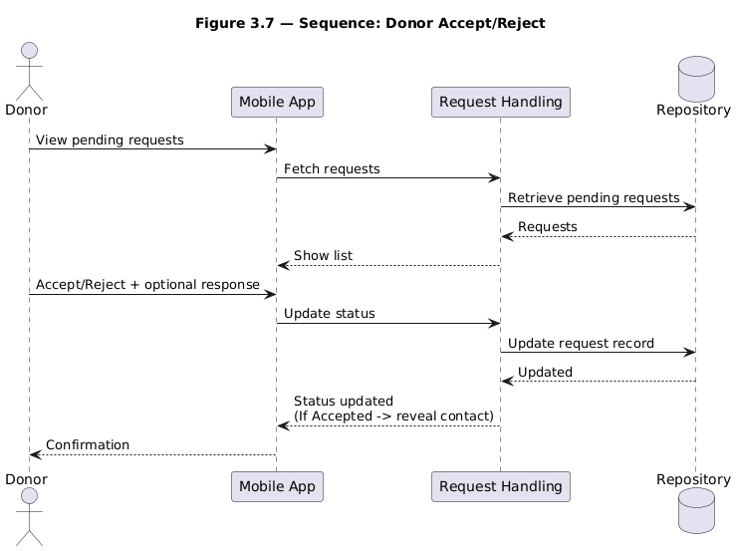
Figure 3.7 Sequence Diagram Donor Accept/Reject

3.2.4 Interface Specifications (Subsystem-Level)
Subsystem interaction is defined through logical service interfaces (design-level, not implementation code). The following interface responsibilities are defined:
- Authentication Interface
- Inputs: username, password, selected role
- Outputs: authenticated session, role-based access decision
- Errors: invalid credentials, unauthorized role selection
- Profile Management Interface
- Inputs: profile updates (phone, city, image), availability state
- Outputs: updated profile state
- Errors: invalid data, missing required fields (donor-specific)
- Search & Matching Interface
- Inputs: blood group, city/area filter
- Outputs: list of matching donors
- Errors: invalid filter input, no matching donors
- Request Handling Interface
- Inputs: donor selection, request details, accept/reject action, optional response
- Outputs: request status updates, visibility control of contact information
- Errors: duplicate request, request limit exceeded, unauthorized actions
- Admin Management Interface
- Inputs: filters (role, city, date range, status)
- Outputs: dashboards, lists, record details
- Errors: access denied, missing/corrupted records

3.3 Design Rationale
The architecture of the BloodLink (Smart Blood Donation System) was selected to support scalability, maintainability, role-based access, and clear separation of responsibilities. A modular, layered architectural approach was chosen to ensure that the system can evolve over time while remaining easy to understand and manage.
Selected Architecture
BloodLink adopts a client–server layered architecture in which user-facing clients communicate with a centralized backend responsible for business logic and data management. This approach enables consistent enforcement of system rules, centralized control of data integrity, and simplified coordination between donors, recipients, and administrators.
The modular decomposition into subsystems—such as authentication, donor management, search and matching, request handling, and administration—allows each functional area to evolve independently. This reduces coupling between components and improves maintainability. Role-based access was favored over role-specific applications to allow users to switch roles (e.g., donor to recipient) without maintaining separate accounts.
Trade offs and Design Considerations
Several architectural trade-offs were evaluated during the design process:
- Client–Server vs. Standalone Application:
A standalone or purely local application was considered but rejected because it would not support real-time coordination between multiple users or centralized monitoring by administrators.
- Monolithic vs. Modular Backend:
A fully monolithic backend design was avoided to reduce complexity and improve testability. Instead, logical subsystem boundaries were defined to support future expansion and clearer responsibility allocation.
- Role-Based Design vs. Separate User Types:
Implementing separate user classes for donors and recipients was considered but not selected. A role-based approach was chosen to simplify user management and support scenarios where a single user may act as both donor and recipient at different times.
- Direct Data Access vs. Controlled Data Repository:
Direct interaction between subsystems and persistent storage was avoided. A centralized data persistence approach was selected to ensure data consistency, security, and controlled access.
Rejected Alternatives
Alternative architectures such as peer-to-peer communication between users and tightly coupled client-side logic were considered but rejected due to concerns regarding data security, synchronization complexity, and limited administrative oversight.
Summary
The selected architecture balances flexibility, security, and clarity. It supports the system’s functional goals while minimizing complexity and enabling future enhancements. The design choices documented in this section provide a stable foundation for implementation while remaining adaptable to evolving system requirements.

4. DATA DESIGN

4.1 Data Description
The information domain of the BloodLink (Smart Blood Donation System) is transformed into structured data entities that represent users, donor profiles, blood donation requests, and administrative records. These entities capture both static information (such as user details and blood groups) and dynamic information (such as availability status and request lifecycle states).
At a design level, the system organizes data into logical entities that reflect real-world concepts and interactions within the blood donation process. Each entity is uniquely identifiable and related to others through well-defined associations to support efficient processing and retrieval.
Major Data Entities
- User Data:
Represents authenticated system accounts. User data is used for identity management, access control, and role determination.
- Profile Data:
Stores extended user information such as contact details, city/area, donor status, blood group (for donors), profile image, and availability state. Profile data enables donor discovery and filtering.
- Blood Request Data:
Represents requests initiated by recipients to donors. Each request contains patient information, request details, timestamps, status indicators, and optional donor responses. This data supports request tracking and historical reporting.
- Administrative Data:
Aggregates system-level information such as user listings, request logs, and monitoring data required for administrative oversight.
Data Storage and Organization
All system data is stored in a centralized persistent data repository. Logical relationships between entities are maintained to ensure data integrity, such as the association between users and their profiles, and between users and blood requests. Data access is controlled through structured operations that prevent unauthorized modification and ensure consistency across subsystems.
Data Processing Overview
Data is processed in response to user actions and system events. For example:
- User and profile data is processed during registration, login, and profile updates.
- Donor availability and profile data is processed during donor search and matching.
- Blood request data is processed throughout its lifecycle, from creation to completion.
This structured data design supports reliable system operation, efficient retrieval, and scalability as the system grows.

4.2 Data Dictionary
This section presents the data dictionary for the BloodLink (Smart Blood Donation System). It lists the major system objects identified in the object-oriented decomposition along with their attributes and brief descriptions. The data dictionary provides a clear understanding of how information is represented and organized within the system design.
4.2.1 Admin (Logical Role Object)
Attribute | Description
admin_id | Unique identifier for the administrator
role | Indicates administrative privileges
access_level | Defines scope of management permissions

Methods (Design-Level):
Method | Description
viewDashboard() | Displays system statistics and summaries
manageUsers() | Allows inspection of donor and recipient accounts
viewRequests() | Displays system-wide blood request records

4.2.2 BloodRequest
Attribute | Description
request_id | Unique identifier for the blood request
patient_name | Name of the patient requiring blood
blood_group | Required blood group
city | Location of the request
hospital_name | Hospital where blood is needed
message | Custom message from the recipient
status | Current state of the request (Pending, Accepted, Rejected, Fulfilled)
created_at | Timestamp when the request was created
donor_response | Optional response message from the donor

Methods (Design-Level):
Method | Description
createRequest() | Creates a new blood request
updateStatus() | Updates the request status
addResponse() | Stores donor’s response message

4.2.3 Profile
Attribute | Description
profile_id | Unique identifier for the profile
phone_number | Contact number of the user
blood_group | Blood group (applicable to donors only)
city | User’s city or area
is_donor | Indicates whether the user acts as a donor
available | Indicates donor availability status
image | Optional profile image
Methods (Design-Level):
Method | Description
updateProfile() | Updates profile information
setAvailability() | Changes donor availability status
getProfileDetails() | Retrieves profile information

4.2.4 User
Attribute | Description
user_id | Unique identifier for the user
username | Login name of the user
email | Registered email address
password_hash | Encrypted authentication credential
first_name | User’s display name
role | Active role (Donor, Recipient, Admin)

Methods (Design-Level):
Method | Description
authenticate() | Validates user credentials
selectRole() | Determines active role after login
logout() | Ends the user session

4.2.5 SystemRepository (Logical Data Store)
Attribute | Description
users | Collection of user records
profiles | Collection of profile records
requests | Collection of blood request records

Methods (Design-Level):
Method | Description
saveData() | Stores new or updated records
retrieveData() | Fetches stored records
updateData() | Modifies existing records

5. COMPONENT DESIGN
This section provides a systematic design-level description of the major object member functions identified in Section 3.2. The goal is to summarize how each component behaves in response to inputs, while remaining implementation-independent. The descriptions below use Procedural Description Language (PDL) / pseudocode and include local data where necessary.

5.1 User Component (Account & Role Behavior)
5.1.1 authenticate(username, password)
Purpose: Verify user credentials and establish authenticated access.
PDL / Pseudocode:
- INPUT: username, password
- OUTPUT: authentication_status, user_session or error_message
- Retrieve user_record matching username
- IF user_record not found THEN
  - return error_message = "Invalid credentials"
- Compare provided password with stored credential (secure verification)
- IF verification fails THEN
  - return error_message = "Invalid credentials"
- Create authenticated session for user
- return authentication_status = SUCCESS and session_reference
Local Data:
- user_record
- verification_result

5.1.2 selectRole(user, selected_role)
Purpose: Activate donor or recipient workflow based on selected role.
PDL / Pseudocode:
- INPUT: user, selected_role
- OUTPUT: dashboard_route or access_denied
- IF selected_role = "Admin" AND user is not privileged THEN
  - return access_denied
- IF selected_role = "Donor" THEN
  - IF user.profile.is_donor is FALSE THEN return access_denied
  - ELSE return donor_dashboard_route
- IF selected_role = "Recipient" THEN
  - return recipient_dashboard_route
- ELSE return error_message = "Invalid role selection"
Local Data:
- role_validation_flag

5.2 Profile Component (User Profile & Donor Availability)
5.2.1 updateProfile(profile, updated_fields)
Purpose: Update user profile details (name/contact/city/image).
PDL / Pseudocode:
- INPUT: profile, updated_fields
- OUTPUT: success_message or validation_error
- Validate updated_fields (format, missing critical fields)
- IF validation fails THEN return validation_error
- Update profile attributes with provided values
- Save updated profile
- return success_message = "Profile updated successfully"
Local Data:
- validation_errors
5.2.2 setAvailability(profile, availability_state)
Purpose: Toggle donor availability (Online/Offline).
PDL / Pseudocode:
- INPUT: availability_state (TRUE/FALSE)
- OUTPUT: updated_availability_state
- IF profile.is_donor is FALSE THEN
  - return error_message = "Only donors can update availability"
- Set profile.available = availability_state
- Save profile
- return updated_availability_state
Local Data:
- previous_state

5.3 BloodRequest Component (Request Lifecycle Management)
5.3.1 createRequest(sender, receiver, request_details)
Purpose: Create a new blood request from recipient to donor.
PDL / Pseudocode:
- INPUT: sender, receiver, request_details
- OUTPUT: request_id or error_message
- IF receiver is not an eligible donor OR receiver is not available THEN
  - return error_message = "Donor not available"
- Check if there is already a pending request from sender to receiver
- IF duplicate pending request exists THEN
  - return error_message = "Request already pending"
- Count sender’s active pending requests
- IF pending_count >= system_limit THEN
  - return error_message = "Request limit exceeded"
- Create new BloodRequest object with status = "Pending"
- Save request to repository
- return request_id
Local Data:
- pending_count
- duplicate_flag
5.3.2 updateStatus(request_id, action, response_message_optional)
Purpose: Accept, Reject, or Fulfill a request based on donor action or system rule.
PDL / Pseudocode:
- INPUT: request_id, action, optional response_message
- OUTPUT: updated_status or error_message
- Retrieve request by request_id
- IF request not found THEN return error_message = "Request not found"
- IF action not in {Accepted, Rejected, Fulfilled} THEN
  - return error_message = "Invalid action"
- Update request.status = action
- If response_message provided THEN set request.donor_response = response_message
- Save updated request
- return updated_status
Local Data:
- request_record
5.3.3 discloseContactIfAccepted(request)
Purpose: Reveal donor contact details only after acceptance.
PDL / Pseudocode:
- INPUT: request
- OUTPUT: contact_visible (TRUE/FALSE)
- IF request.status = "Accepted" THEN
  - set contact_visible = TRUE
- ELSE
  - set contact_visible = FALSE
- return contact_visible
Local Data:
- contact_visible
5.3.4 autoFulfillRemainingRequests(sender, patient_name, time_window)
Purpose: Auto-close remaining requests when sufficient acceptance events occur for the same patient within a time window.
PDL / Pseudocode:
- INPUT: sender, patient_name, time_window
- OUTPUT: fulfilled_count
- Retrieve accepted_requests for sender and patient_name within time_window
- IF accepted_requests_count >= threshold THEN
  - Retrieve pending_requests for sender and patient_name within time_window
  - FOR each pending_request in pending_requests
    - set status = "Fulfilled"
    - set donor_response = system_auto_message
    - Save pending_request
- return fulfilled_count
Local Data:
- accepted_requests_count
- pending_requests_list
- threshold
- system_auto_message

5.4 Admin Component (Monitoring & Management)
5.4.1 viewDashboard
Purpose: Display summary metrics for admin monitoring.
PDL / Pseudocode:
- INPUT: optional filters (date, status)
- OUTPUT: metrics_summary
- Verify admin privileges
- Retrieve total users, total donors, total recipients
- Retrieve request counts by status (pending/active/fulfilled)
- Apply optional filters if provided
- return metrics_summary
Local Data:
- metrics_summary object
5.4.2 manageUsers
Purpose: Retrieve and view user lists with filtering.
PDL / Pseudocode:
- INPUT: criteria_optional (role, city)
- OUTPUT: user_list
- Verify admin privileges
- Retrieve users based on criteria
- return user_list
Local Data:
- criteria

5.5 SystemRepository Component (Logical Data Store)
5.5.1 saveData(entity)
Purpose: Persist a new entity record.
PDL / Pseudocode:
- INPUT: entity
- OUTPUT: save_status
- Validate entity integrity
- Store entity in persistent repository
- return save_status
5.5.2 retrieveData(entity_type, query_params)
Purpose: Fetch stored records using query parameters.
PDL / Pseudocode:
- INPUT: entity_type, query_params
- OUTPUT: records_list
- Validate query_params
- Retrieve matching records from repository
- Return records_list
5.5.3 updateData(entity_id, updated_fields)
Purpose: Update existing records.
PDL / Pseudocode:
- INPUT: entity_id, updated_fields
- OUTPUT: update_status
- Retrieve entity by entity_id
- IF entity not found THEN return error
- Apply updated_fields
- Save changes
- return update_status

6. HUMAN INTERFACE DESIGN

6.1 Overview of User Interface
The user interface of the BloodLink (Smart Blood Donation System) is designed to provide a clear, intuitive, and role-based interaction experience for all system users, including donors, recipients, and administrators. From the user’s perspective, the system enables essential tasks to be completed with minimal effort while providing timely and meaningful feedback at each step.
User Interaction Flow
Upon launching the system, users are guided through authentication and role selection. Based on the selected role, the interface dynamically presents relevant features and navigation options. Donors, recipients, and administrators each interact with tailored interfaces that expose only the functionality appropriate to their role.
Recipient Experience
Recipients use the interface to:
- Browse and select blood groups.
- Apply location-based filters to search for available donors.
- View donor details such as blood group, city/area, and availability status.
- Submit blood donation requests with custom messages.
- Track the status of submitted requests and review request history.
The system provides clear feedback messages for actions such as successful request submission, request status updates, and situations where no suitable donors are found.
Donor Experience
Donors interact with the interface to:
- View incoming blood donation requests.
- Accept or reject requests and optionally provide a response message.
- Update their availability status (online/offline).
- Manage their profile information.
Feedback is provided to donors in the form of confirmation messages, request updates, and visibility indicators that reflect their current availability and request status.
Administrator Experience
Administrators access the system through a web-based interface that allows them to:
- Monitor overall system activity through dashboards.
- View lists of users, donors, recipients, and blood requests.
- Apply filters to inspect specific records.
- Review system statistics and request logs.
The interface provides structured views and summaries that support efficient monitoring and decision-making without interfering with donor–recipient workflows.

6.2 Project Screen Images
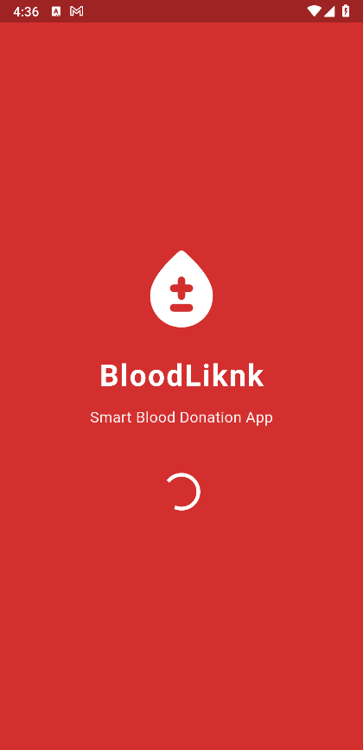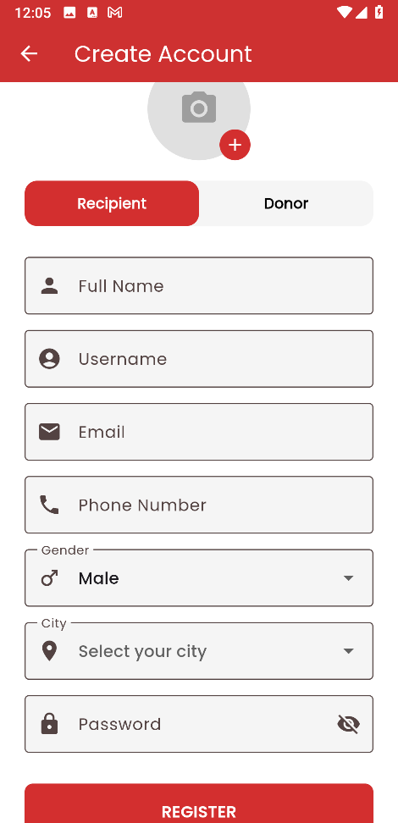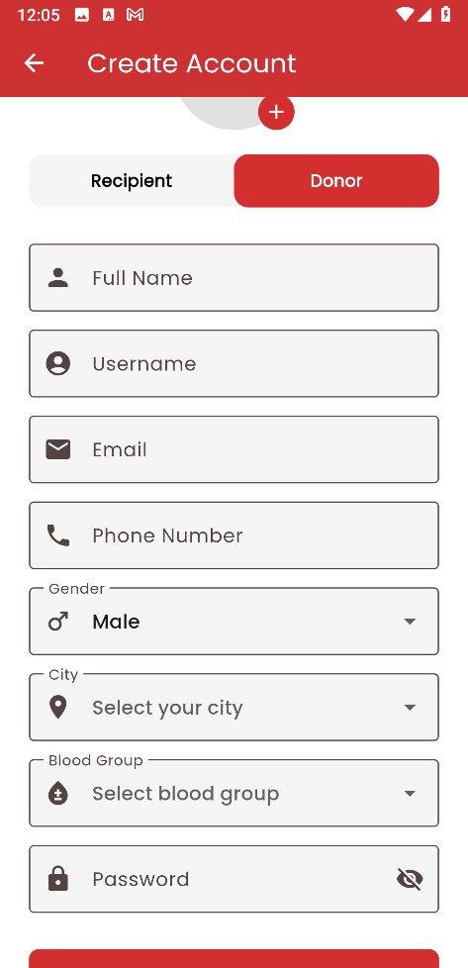
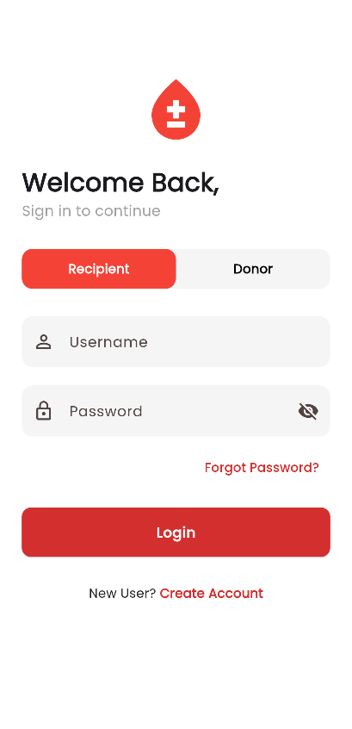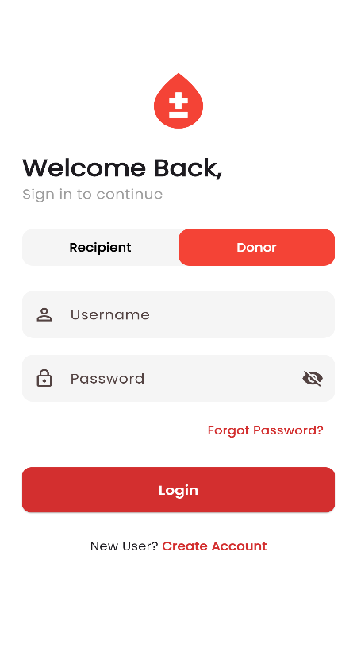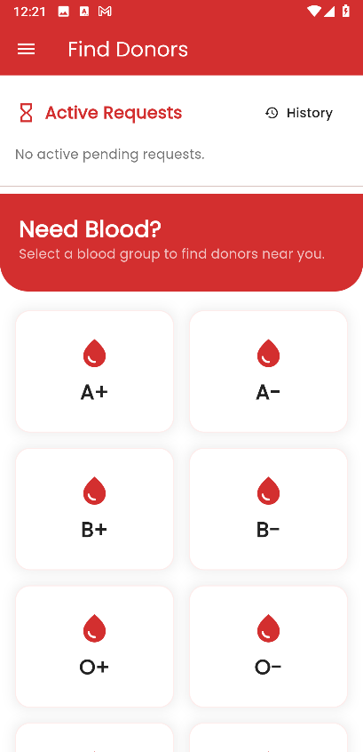

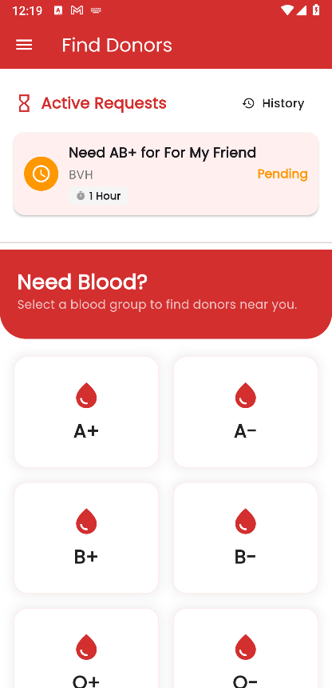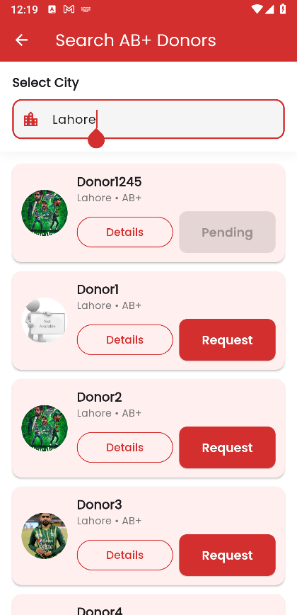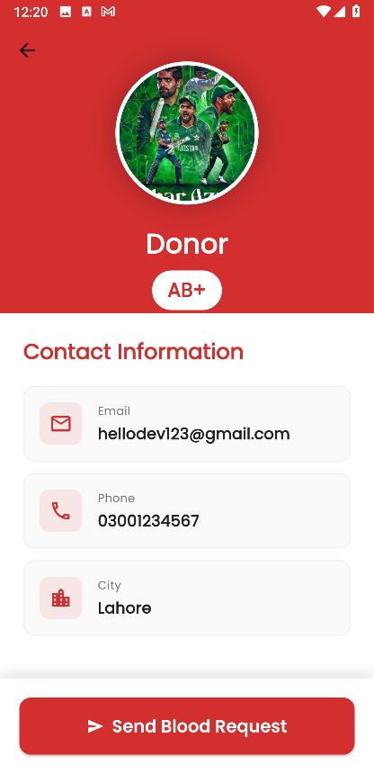

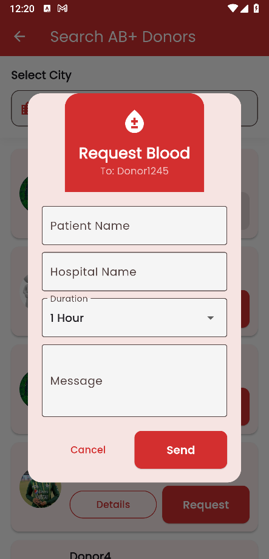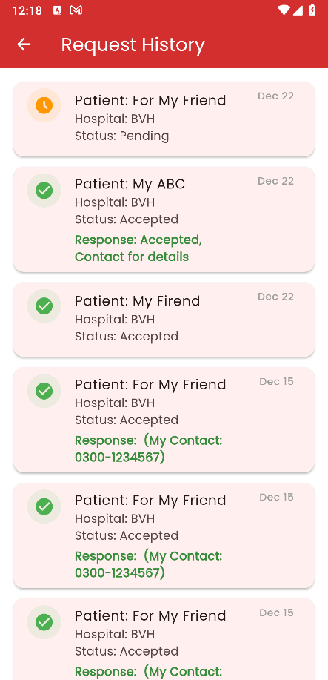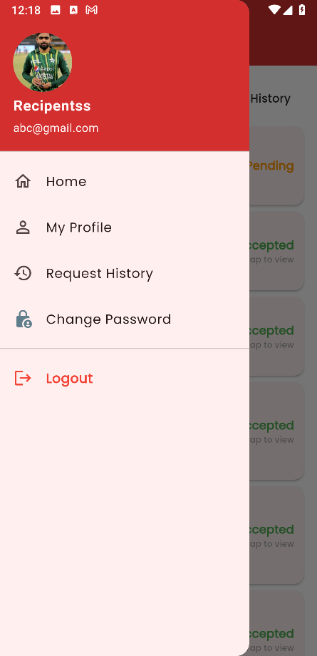

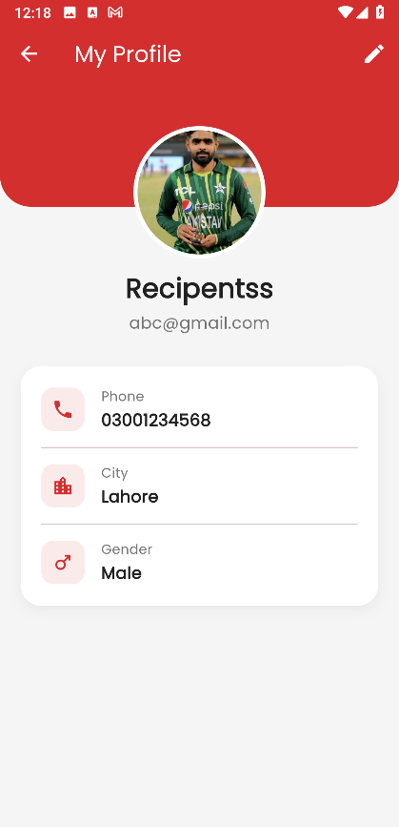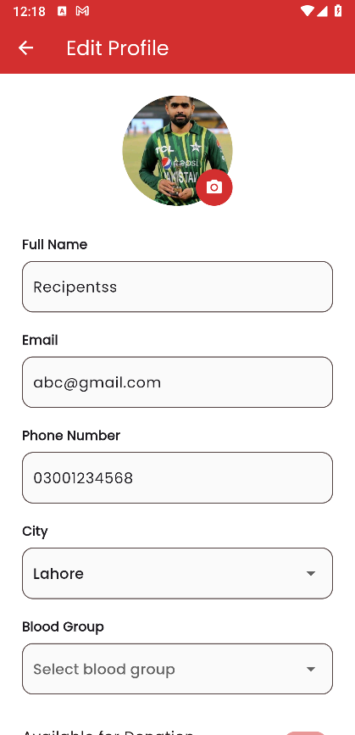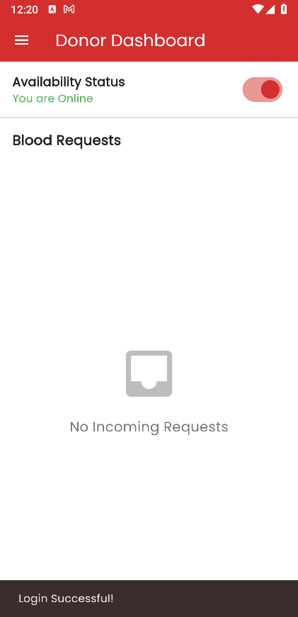

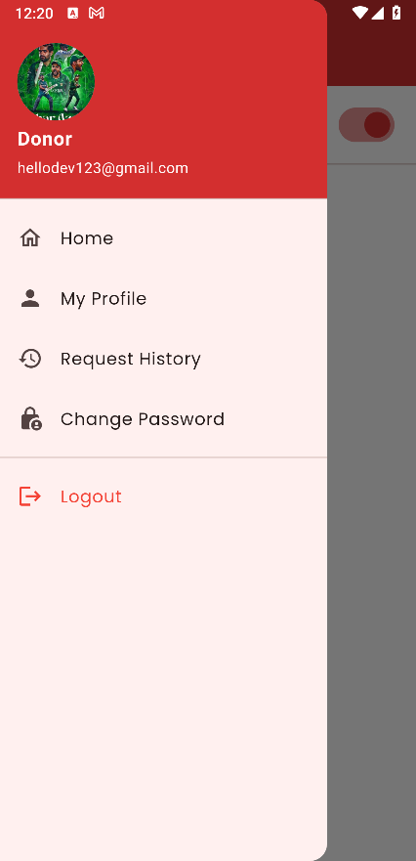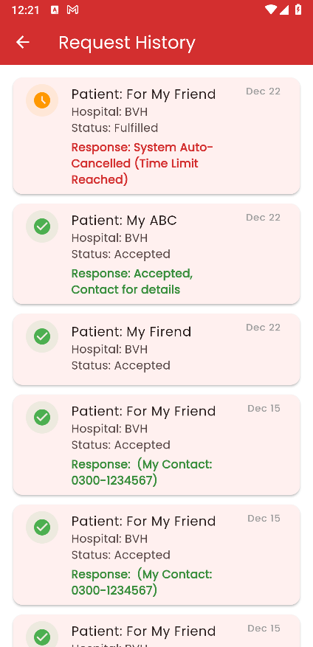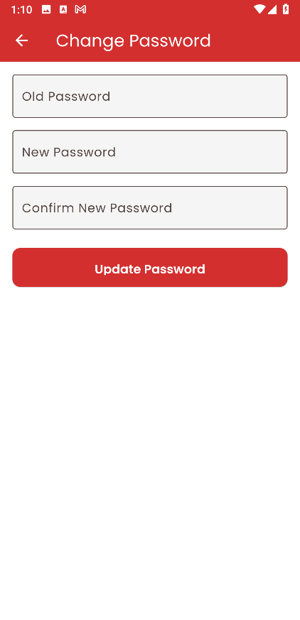

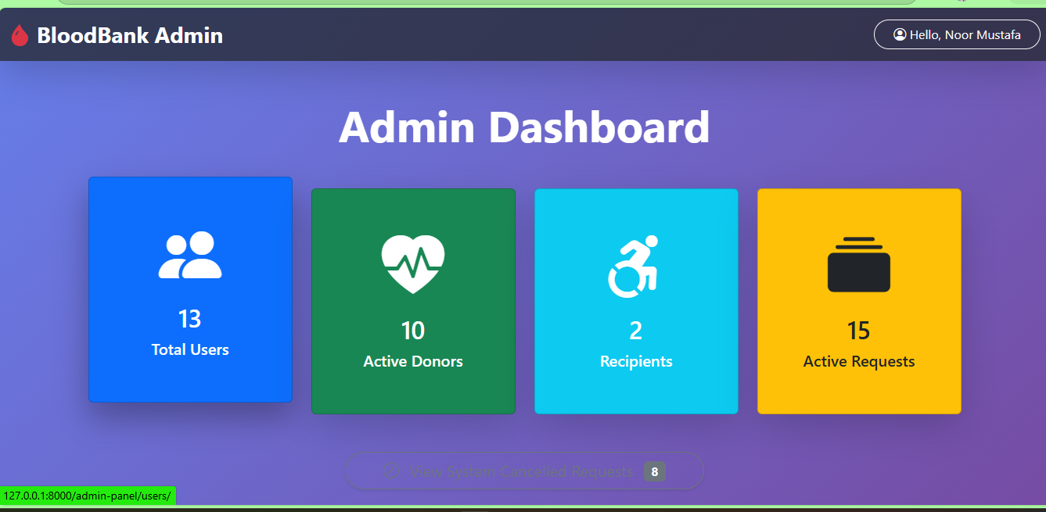

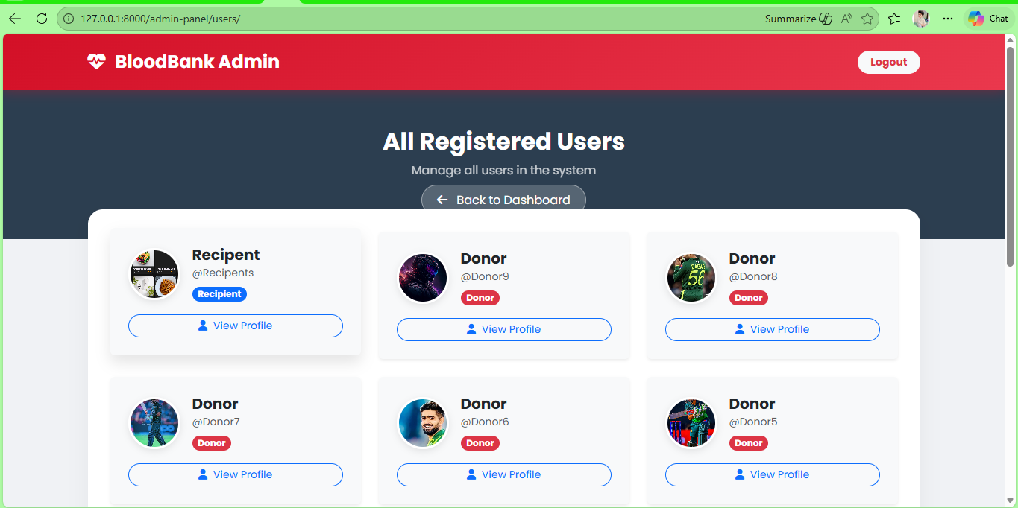

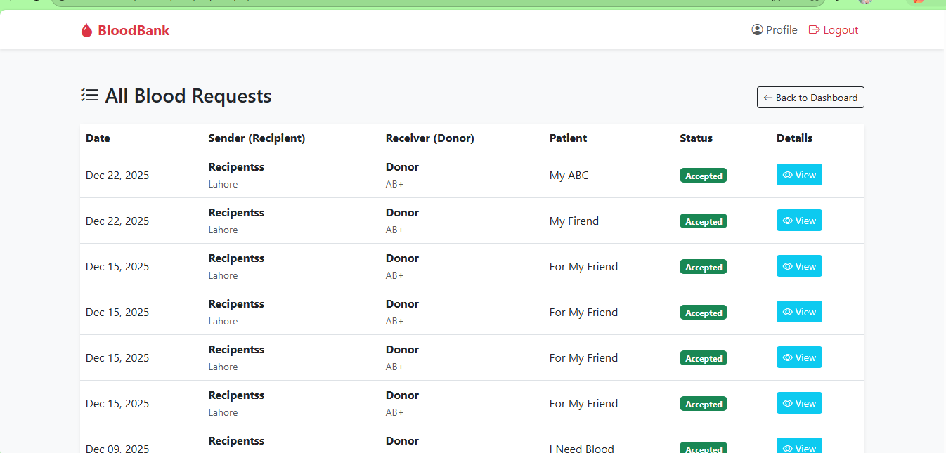

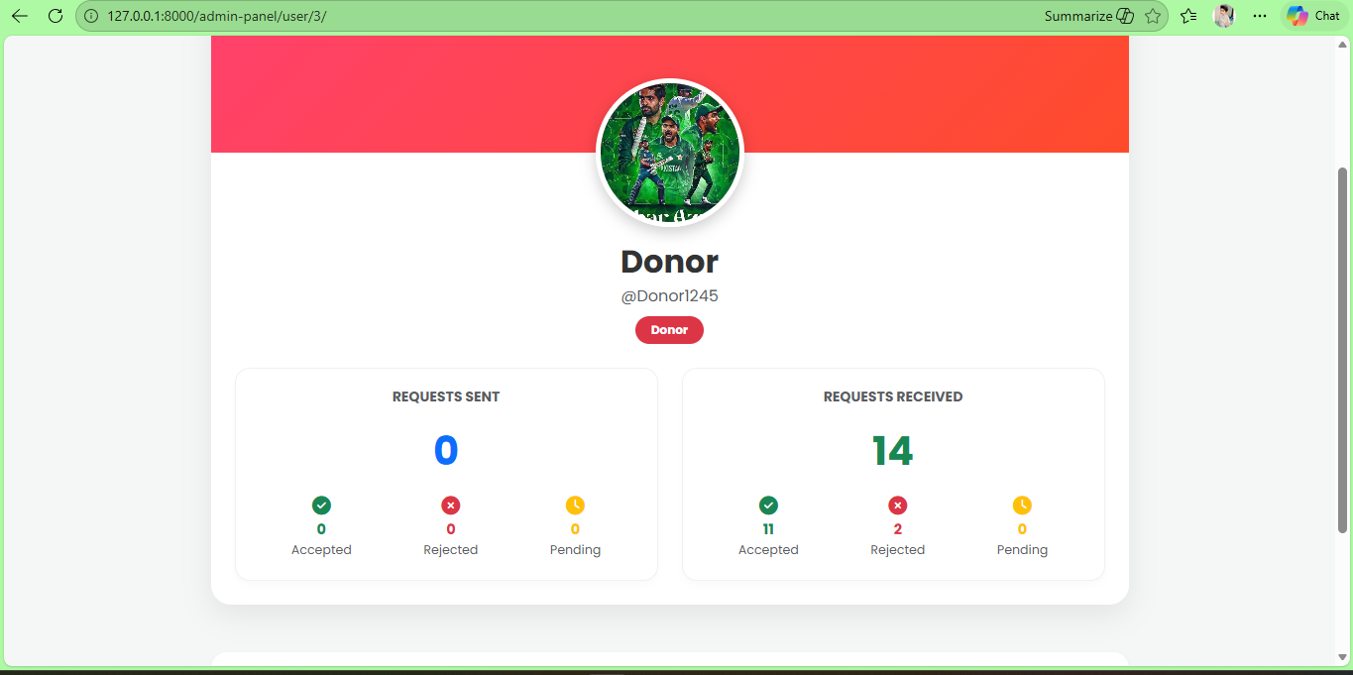

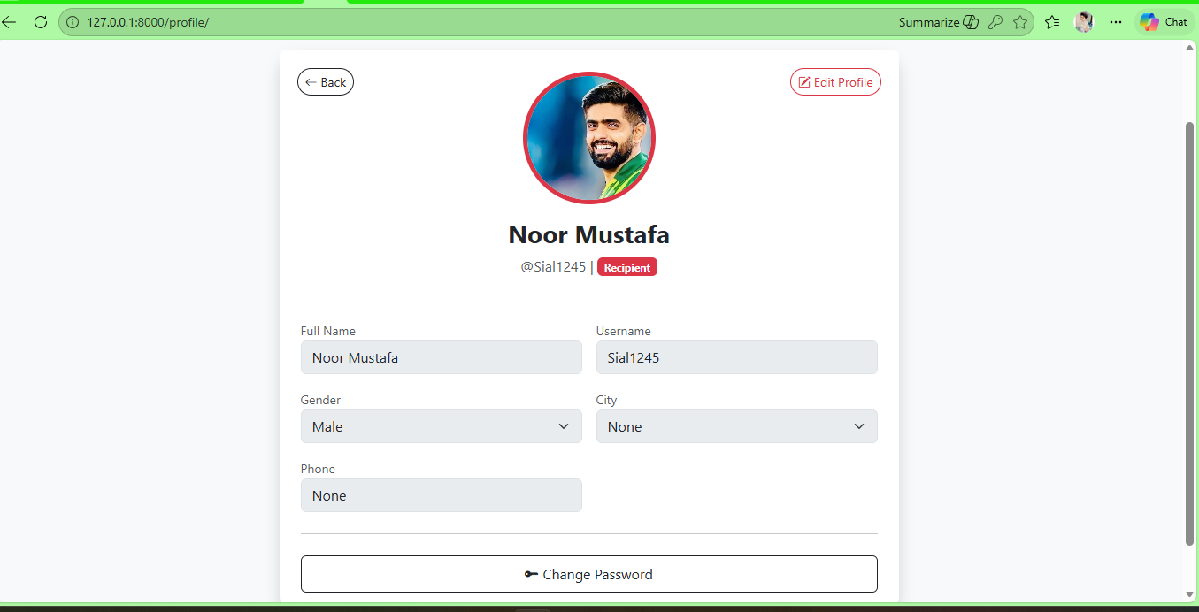

6.3 Screen Objects and Actions
This subsection describes the major screen objects used in the BloodLink (Smart Blood Donation System) and the actions associated with those objects. The screens are grouped by functional purpose and user role to avoid redundancy and to clearly explain how users interact with the system.
6.3.1 Splash and Authentication Screens
Screen Objects:
- Application logo and branding elements
- Role selection toggle (Donor / Recipient)
- Text fields for username and password
- Buttons: Login, Create Account, Forgot Password
Actions:
- Displays system branding during application startup.
- Allows users to select their intended role.
- Validates credentials upon login.
- Navigates users to registration or password recovery screens when selected.
6.3.2 User Registration Screens
Screen Objects:
- Input fields for personal details (name, username, email, phone number)
- Password and confirm password fields
- City selection dropdown
- Blood group dropdown (visible for donor role)
- Profile image upload control
- Register button
Actions:
- Collects user registration information.
- Validates required inputs and role-specific fields.
- Submits data for account creation.
- Displays success or validation error messages.
6.3.3 Recipient Home and Donor Search Screens
Screen Objects:
- Blood group selection cards
- City/area selection field
- Donor list cards with profile preview
- Action buttons: Details, Request
- Notification and request status indicators
Actions:
- Enables recipients to select blood groups.
- Filters donors based on city and availability.
- Displays matching donor profiles.
- Initiates blood request workflow.
6.3.4 Blood Request Creation Screens
Screen Objects:
- Input fields for patient name, hospital name, duration, and message
- Confirmation and cancel buttons
- Status labels (Pending, Accepted, Rejected)
Actions:
- Allows recipients to submit blood donation requests.
- Validates request limits and duplicate requests.
- Displays confirmation upon successful submission.

6.3.5 Request History Screens
Screen Objects:
- Request list items
- Status icons and timestamps
- Navigation menu options
Actions:
- Displays past and active requests.
- Shows current request status and response details.
- Allows users to review historical activity.
6.3.6 Donor Dashboard Screens
Screen Objects:
- Availability toggle (Online / Offline)
- Incoming request cards
- Action buttons: Accept, Reject
- Contact information popup
Actions:
- Allows donors to manage availability status.
- Displays incoming blood requests.
- Processes accept or reject actions.
- Reveals contact information upon request acceptance.
6.3.7 Profile Management Screens
Screen Objects:
- Profile image display
- Editable personal information fields
- Edit Profile and Save buttons
Actions:
- Displays user profile details.
- Allows users to update personal information.
- Saves changes and reflects updates across the system.

6.3.8 Password Management Screens
Screen Objects:
- Old password field
- New password and confirm password fields
- Update Password button
Actions:
- Validates existing credentials.
- Updates password securely.
- Displays confirmation or error messages.
6.3.9 Administrative Web Interface Screens
Screen Objects:
- Dashboard summary cards (users, donors, recipients, requests)
- User and request lists
- View and navigation buttons
- Logout control
Actions:
- Displays system statistics and metrics.
- Allows administrators to view users and requests.
- Supports system monitoring and oversight.
- Enables secure administrative logout.

7. REQUIREMENTS MATRIX

SRS Req ID | Functional Requirement (SRS Title) | Components that Satisfy Requirement | Data Structures / Entities
3.2.1 | User Registration | Mobile App UI, Authentication & Role Mgmt, Profile Management, Repository | User, Profile
3.2.2 | User Login / Authentication | Mobile App UI, Authentication & Role Mgmt, Repository | User, Profile
3.2.3 | Donor Profile Management | Mobile App UI, Profile Management, Repository | Profile, User
3.2.4 | Donor Search & Matching (Recipient) | Mobile App UI, Search & Matching, Request Handling, Repository | Profile, BloodRequest
3.2.5 | Blood Request Creation (Recipient → Donor) | Mobile App UI, Request Handling, Repository | BloodRequest, User, Profile
3.2.6 | Donor Request Handling (Accept/Reject) | Mobile App UI, Request Handling, Profile Management, Repository | BloodRequest, Profile
3.2.7 | Request History (Donors & Recipients) | Mobile App UI, Request Handling, Repository | BloodRequest
3.2.8 | Admin Management & Monitoring | Admin Web UI, Admin Monitoring & Management, Authentication & Role Mgmt, Repository | User, Profile, BloodRequest
3.2.9 | Password Management | Mobile App UI, Authentication & Role Mgmt, Repository | User

8. APPENDICES
This section contains supplementary information that supports the understanding of the BloodLink (Smart Blood Donation System) Software Design Document (SDD) but is not essential to the core design description. The appendices provide additional material that may be useful for reviewers, developers, or instructors who require further clarification or reference.
The following types of information may be included in this section:
- Exported UML diagrams (use case, class, sequence, and architecture diagrams) used to illustrate system behavior and structure.
- https://plantuml.com
- Screen captures of the mobile application and administrative interface referenced in the Human Interface Design section.
- https://screenrec.com/screen-recorder/
- Extended data definitions or notes that complement the Data Dictionary.
- Any assumptions, design notes, or clarifications that are relevant to the system design but do not fit naturally within the main sections of this document.
All appendices included here are optional and are provided for reference only. They do not introduce new system requirements or design constraints and do not alter the approved scope or architecture of the BloodLink system.

